##$$Plot Data into a Map

This program plots measurements (linears or planes) onto a map. Data can be entered in the following ways:
1) manual input
2) from a file
3) from a sample map
4) from an Excel file

The program needs the coordinates of the data points (geographic coordinates as dd°mm.mmm',or dd°mm'ss.s''), Gauss-Krueger coordinates or UTM-Coordinates), and azimut and dip angle of the measures, together with a symbol for linears or planes.
Measures can be entered using a 0..360° or 0..400gon scale. Input from a file is always with 0..360°.
For manual input and input from a map, the sectors (NE, SE, SW, NW) are needed to find the geographic coordinates. NE means northern latitude and eastern longitude, the other sectors are used in a similar sense.
##$$KK>>Geographic Coordinates

Geographic coordinates are measured as latitude and longitude. The latitude is a small circle parallel to the equator (0° to 90° north and 0° to 90° south).

Longitudes are great circles connecting the north and the south pole. (0° to 180° east and 0° to 180° west).

##$$Manual Data Input

In case you use geographic coordinates,you have to set the format of the position data . If you want to use Gauss-Krueger, or UTM coordinates, the coordinates are easting and northing.

These data either found by GPS or read from a map.

The measures must be marked with 'p' for planes or 'l' for linears.

##$$KK>>Position Data
Geographic coordinates can be noted in two different formats: dd°mm.mmmm' or dd°mm'ss.s''.
##$$KK>>dd°mm.mmmm'
This is a format for geographic coordinates. Two digits for the degree, two digits for full minutes and three digits after the decimal point (example: 45°31.2345').
##$$KK>>dd°mm'ss.s''
This is a format for geographic coordinates. It means: two digits for degree, two digits for minutes, two digits for full seconds, and one digit after the decimal point (example: 45°31'23.4'').
##$$KK>>Gauss-Krueger-Coordinates

These coordinates were created by Carl Friedrich Gauss and Johann Heinrich Louis Krueger: The earth is divided in strips of meridians of 3° width. Each strip connects the south and the north pole. The middle meridian is in the middle of the strip. Each strip is numbered according to the middle meridian.(0°, 3°, 6°,...give the numbers 0, 1, 2,...). The coordinates of a point are given by easting and northing. The easting value is defined by the distance from the middle meridian in meters. (To avoid negative values a value of 500 km is added). Northing is the distance from the equator measured along the middle meridian.
##$$KK>>Easting
see Gauss-Krueger coordinates.
##$$KK>>Northing
see Gauss-Krueger coordinates.
##$$Plot of the Map
This program plots the map with strike and dip symbols for planes and arrows for linears. The map is drawn either with geographic coordinates, Gauss-Krueger, or UTM-coordinates. In the menu 'margins of the map' The frame of the map can be increased or decreased, or the coordinates of the margin can be redefined. The purpose of the latter is to overlay a map, a digital elevation model, or a satellite image. Fill in the coordinates of the margins of this image to make sure that the image will not be distorted. Overlay is done in the menu 'Diagram' either from clipboard or from a file. In the same menu the new map may be served and/or printed.
##$$Input from a File
Data are saved in files with the extension '*.map' as geographic coordinates Gauss-Krueger or UTM coordinates, and azimuths of dip und dip angle. All files with extension '*.map' of the chosen folder appear in the right list field (The folder is changed with the button 'change directory'). Click on the file with which you want to draw a map. You may also click on more than one file, if you want to draw a map for several files. The choice of files is terminated with the button 'selection ok'. The data of all chosen files appear in the left list field. With the button 'plot' you reach the graphic screen which displays the map.
##$$Data Points from a Map
The programm finds the geographic, Gauss-Krueger, or UTM coordinates of a point, indicated in the map. The map must already exist as a '*.bmp' or '*.jpg' file, or on the clipboard. It can then be imported. The margins of the map are typed into the relevant fields either as geograhic, Gauss-Krueger, or UTM-coordinates. If data points are marked on the backside of a map, the map is drawn back to front.

Procedure:
1) Decide in the menu 'import map', whether the map is imported from a data carrier or from the clipboard.
2) Indicate in the menu 'marking of data locations', whether the map is drawn with the front side or back to front.
3) Type the coordinates of the margins in the relevant fields.
4) Click on the data points.
5) Mark the fabric type with 'p' for planes or 'l' for linears, type azimuth and dip angle.
6) Click on 'terminate input' when all points are clicked.
7) Create the map by clicking on 'plot'.

##$$Data from an Excel File
The Excel file must obey following rules:
1) Latitude and longitude must be written in two separate columns (as dd°mm.mmm', dd°mm'ss.s'', Gauss-Krüger oder UTM).
2) Azimuth and angle of dip may be listed together with a separator in one column or in two separate columns.
3) The value which is written in the same row as the coordinates is plotted.
4) Other text written in these columns is overread.

Procedure:
1) Find the folder.
2) Click on the Excel file.
3) Choose the worksheet.
4) The Excel worksheet is displayed: find the colums for the coordinates and for azimuths and dip angles. Minimize the worksheet.
5) Type the columns for latitude and longitude.
6) Type the columns for azimuth and dip angle.
7) Choose the fabric type.
8) Type the numbers of the first and last row of the choosen area of the worksheet.
9) Type the symbol of the separator if azimuth and dip angle are written in the same column.
10) Click on 'OK'.
##$$KK>>UTM-Coordinates

UTM means 'Universe Transverse Mercator'. The system was introcuced in 1947 it is now established worlwide with exception of the polar regions. The coordinates are found in a similar way as Gauss-Krueger-coordinates, but a meridian strip has a width of 6°. The coordinate axes are also called easting and northing. The earth's surface is divided up.into grid squares (UTM-zone fields).
##$$KK>>UTM-Zone Field

From 180°W to 180°E the earth's surface is devided uo into 60 meridan strips od 6° width. These strips are numbered with zone numbers (No 1 for the strip from 180°W to 174°W, and No 60 for the strip from 174°E to 180°E). The meridan strips are divided up into zone fields from 80°S to 84°N by latitudes in the distance of 8°. These fields are labeled with letters: the southernmost zone has the letter 'C' and the northernmost one has the letter 'X' (The letters I and O are not used in order to avoid confusion with the digits 1 and 0 (s. Fig.).

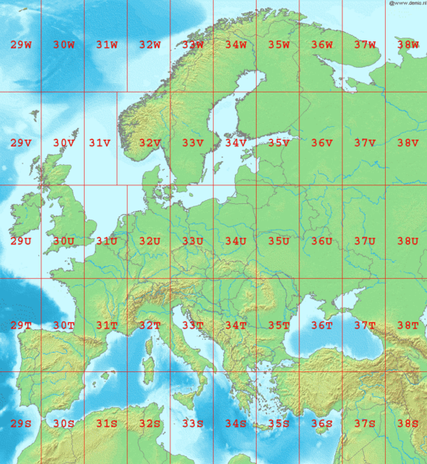
from Wikipedia

# DataIntoMap
$ DataIntoMap
# GeoKoordinaten
$ GeoKoordinaten
Kgeographic coordinates
> Hilfe1
# MapManual
$ MapManual
# PositionData
$ PositionData
K position data
> Hilfe1
# ddmm
$ ddmm
K dd°mm.mmm'
> Hilfe1
# ddms
$ ddms
K dd°mm'ss.s''
> Hilfe1
# Gauss-Krueger
$ Gauss-Krueger
K Gauss-Krueger-coordinates
> Hilfe1
# Easting
$ Northing
K Easting
> Hilfe1
# Northing
$ Northing
K Northing
> Hilfe1
# PlotMap
$ PlotMap
# MapFromFile
$ MapFromFile
# DataFromMap
$ DataFromMap
# MapFromExcel
$ MapFromExcel
# UTM
$ UTM
K UTM-coordinates
> Hilfe1
# UTMZone
$ UTMZone
K UTM-zone field
> Hilfe1

